RETAIL STORE SALES DATA VISUALIZATION AND ANALYSIS USING R

Task 2 – Data Visualization
Submitted by: Aashin N
Role: Virtual R Data Analyst Intern

1. Introduction
The objective of this task is to create informative and meaningful data visualizations using R. Data visualization helps transform numerical and categorical data into graphical representations that make trends, patterns, relationships, distributions, and anomalies easier to identify and communicate.
For this task, the cleaned Retail Store Sales dataset from Task 1 was used. Continuing with the same dataset allowed the visualization process to be performed on data that had already been cleaned, validated, transformed, and prepared for analysis.
The ggplot2 visualization library in R was primarily used to create the graphs. Different visualization techniques were selected depending on the type of variables and the analytical question being investigated.
The visualizations developed in this task include bar charts, a histogram, a scatter plot, a line chart, a box plot, and a grouped bar chart. Each visualization was designed to communicate its findings clearly to both technical and non-technical audiences.

2. Dataset Overview
The Retail Store Sales dataset contains information about individual retail transactions. After the data-cleaning and preprocessing procedures completed in Task 1, the final cleaned dataset contained:
- 11,971 observations
- 18 variables
- 0 missing values
- 0 completely duplicated observations
The dataset contains numerical, categorical, and date-related variables.
Important variables used for visualization include:
Variable | Description
Category | Product category associated with the transaction
Price Per Unit | Price of one unit of the purchased item
Quantity | Number of units purchased
Total Spent | Total transaction value
Payment Method | Method used to complete the payment
Location | Whether the transaction occurred Online or In-store
Transaction Date | Date on which the transaction occurred
Discount Applied | Indicates whether a discount was applied
Year_Month | Year and month extracted for monthly analysis
The cleaned dataset was imported into R for visualization.
clean_data <- read_csv(
"cleaned_data/cleaned_retail_store_sales.csv"
)
The dimensions and structure of the dataset were verified using:
dim(clean_data)
str(clean_data)
The resulting dimensions were:
11,971 observations
18 variables
Because categorical variables imported from CSV files can be represented as character variables, the relevant variables were converted back to factors before visualization.
clean_data$Category <- factor(
clean_data$Category
)

clean_data$`Payment Method` <- factor(
clean_data$`Payment Method`
)

clean_data$Location <- factor(
clean_data$Location
)

clean_data$`Discount Applied` <- factor(
clean_data$`Discount Applied`
)

3. Visualization Tools and Design Approach
The ggplot2 package was selected as the primary visualization library for this task.
library(ggplot2)
ggplot2 was selected because it provides a flexible system for creating professional statistical graphics and allows different graphical components such as axes, labels, geometries, themes, and annotations to be customized.
The visualizations were designed according to the type of data and the analytical question being answered. Bar charts were used for categorical comparisons, a histogram was used to investigate the distribution of a continuous numerical variable, a scatter plot was used to examine the relationship between two numerical variables, a line chart was used for time-based analysis, and a box plot was used to compare numerical distributions across categories.
The visualizations were also designed with clear titles, axis labels, readable category names, and explanatory subtitles so that the findings could be understood by a non-technical audience.

4. Visualization 1 – Total Quantity Sold by Product Category

4.1 Objective
The first visualization was created to answer the following question:
Which product category recorded the highest total quantity sold?
Before creating the visualization, the total Quantity was calculated for each product category.
quantity_by_category <- aggregate(
Quantity ~ Category,
data = clean_data,
FUN = sum
)

quantity_by_category <- quantity_by_category[
order(-quantity_by_category$Quantity),
]

quantity_by_category
The results were:
Category | Total Quantity
Furniture | 8,462
Food | 8,387
Beverages | 8,358
Milk Products | 8,339
Electric household essentials | 8,309
Computers and electric accessories | 8,272
Butchers | 8,206
Patisserie | 7,943

4.2 Visualization Selection
A bar chart was selected because the objective was to compare a numerical value, total Quantity, across multiple categorical groups.
A horizontal layout was used because some category names, such as Computers and electric accessories, are relatively long. Displaying the bars horizontally improves label readability.

4.3 R Code
quantity_category_plot <- ggplot(
quantity_by_category,
aes(
x = reorder(Category, Quantity),
y = Quantity
)
) +
geom_col(width = 0.7) +
geom_text(
aes(label = Quantity),
hjust = -0.15,
size = 3.8
) +
coord_flip() +
scale_y_continuous(
breaks = seq(0, 9000, 1000)
) +
labs(
title = "Total Quantity Sold by Product Category",
subtitle = "Furniture recorded the highest quantity sold",
x = NULL,
y = "Total Quantity Sold"
) +
expand_limits(y = 9000) +
theme_minimal(base_size = 12) +
theme(
panel.grid.major.y = element_blank(),
panel.grid.minor = element_blank(),
plot.title = element_text(
face = "bold",
size = 16
),
plot.subtitle = element_text(size = 11),
axis.text.y = element_text(size = 10),
axis.title.x = element_text(face = "bold")
)

quantity_category_plot
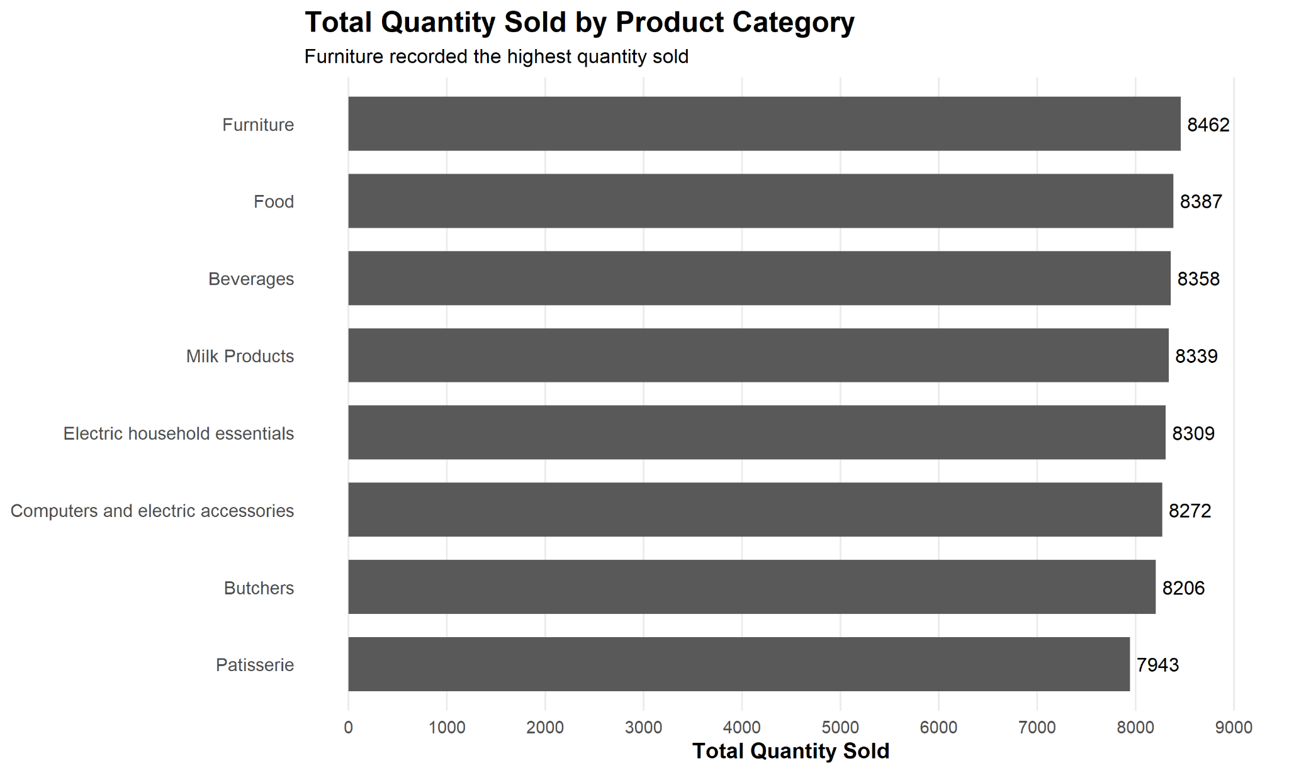
Figure 1: Total Quantity Sold by Product Category

4.4 Interpretation
The visualization shows that Furniture recorded the highest total quantity sold, with 8,462 units, followed by Food with 8,387 units.
Patisserie recorded the lowest total quantity, with 7,943 units.
However, the lengths of the bars are relatively similar across all eight categories. The difference between the highest and lowest categories is only 519 units. Therefore, although Furniture ranked first, the visualization suggests that sales quantity was relatively evenly distributed across the product categories rather than being heavily concentrated in one category.

5. Visualization 2 – Total Revenue by Purchase Location

5.1 Objective
The second visualization was designed to answer:
Which purchase location generates more total revenue?
Revenue was aggregated according to Location.
revenue_by_location <- aggregate(
`Total Spent` ~ Location,
data = clean_data,
FUN = sum
)
revenue_by_location
The results were:
Location | Total Revenue
In-store | 760,670
Online | 791,401

5.2 Visualization Selection
A vertical bar chart was selected because only two categorical groups, Online and In-store, needed to be compared.
The y-axis begins at zero so that the difference between the two locations is represented proportionally rather than visually exaggerated.

5.3 R Code
revenue_location_plot <- ggplot(
revenue_by_location,
aes(
x = Location,
y = `Total Spent`,
fill = Location
)
) +
geom_col(
width = 0.6,
show.legend = FALSE
) +
geom_text(
aes(
label = format(
`Total Spent`,
big.mark = ",",
scientific = FALSE
)
),
vjust = -0.5,
size = 4
) +
scale_y_continuous(
labels = scales::comma,
limits = c(0, 850000)
) +
labs(
title = "Total Revenue by Purchase Location",
subtitle = "Online sales generated slightly higher revenue than in-store sales",
x = "Purchase Location",
y = "Total Revenue"
) +
theme_minimal(base_size = 12) +
theme(
panel.grid.major.x = element_blank(),
panel.grid.minor = element_blank(),
plot.title = element_text(
face = "bold",
size = 16
),
plot.subtitle = element_text(size = 11),
axis.title = element_text(face = "bold")
)

revenue_location_plot
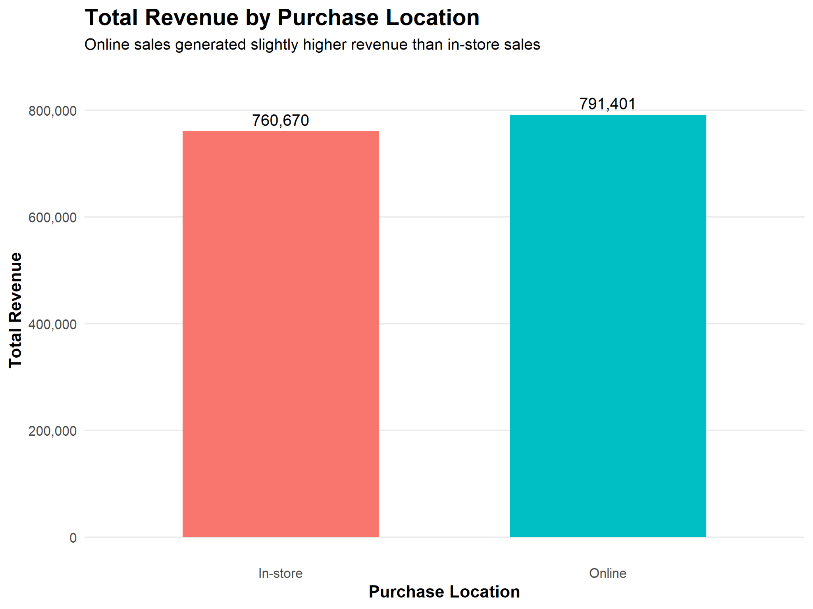
Figure 2: Total Revenue by Purchase Location

5.4 Interpretation
Online transactions generated the highest total revenue at 791,401, compared with 760,670 for In-store transactions.
The difference between the two locations was:
791,401 − 760,670 = 30,731
Therefore, Online generated approximately 30,731 more in total revenue.
However, the two bars remain relatively similar in height, indicating that revenue was broadly balanced between Online and In-store transactions rather than being dominated by one location.

6. Visualization 3 – Distribution of Total Spent

6.1 Objective
The third visualization was created to examine:
How are individual transaction spending values distributed?

6.2 Visualization Selection
A histogram was selected because Total Spent is a continuous numerical variable.
Unlike a bar chart, which compares predefined categories, a histogram groups numerical observations into intervals and shows the number of observations within each interval. This makes it useful for identifying the shape, concentration, spread, and skewness of transaction values.

6.3 R Code
total_spent_histogram <- ggplot(
clean_data,
aes(x = `Total Spent`)
) +
geom_histogram(
bins = 30,
boundary = 0
) +
labs(
title = "Distribution of Total Spent per Transaction",
subtitle = "Most transactions are concentrated at lower spending values",
x = "Total Spent",
y = "Number of Transactions"
) +
theme_minimal(base_size = 12) +
theme(
panel.grid.minor = element_blank(),
plot.title = element_text(
face = "bold",
size = 16
),
plot.subtitle = element_text(size = 11),
axis.title = element_text(face = "bold")
)

total_spent_histogram
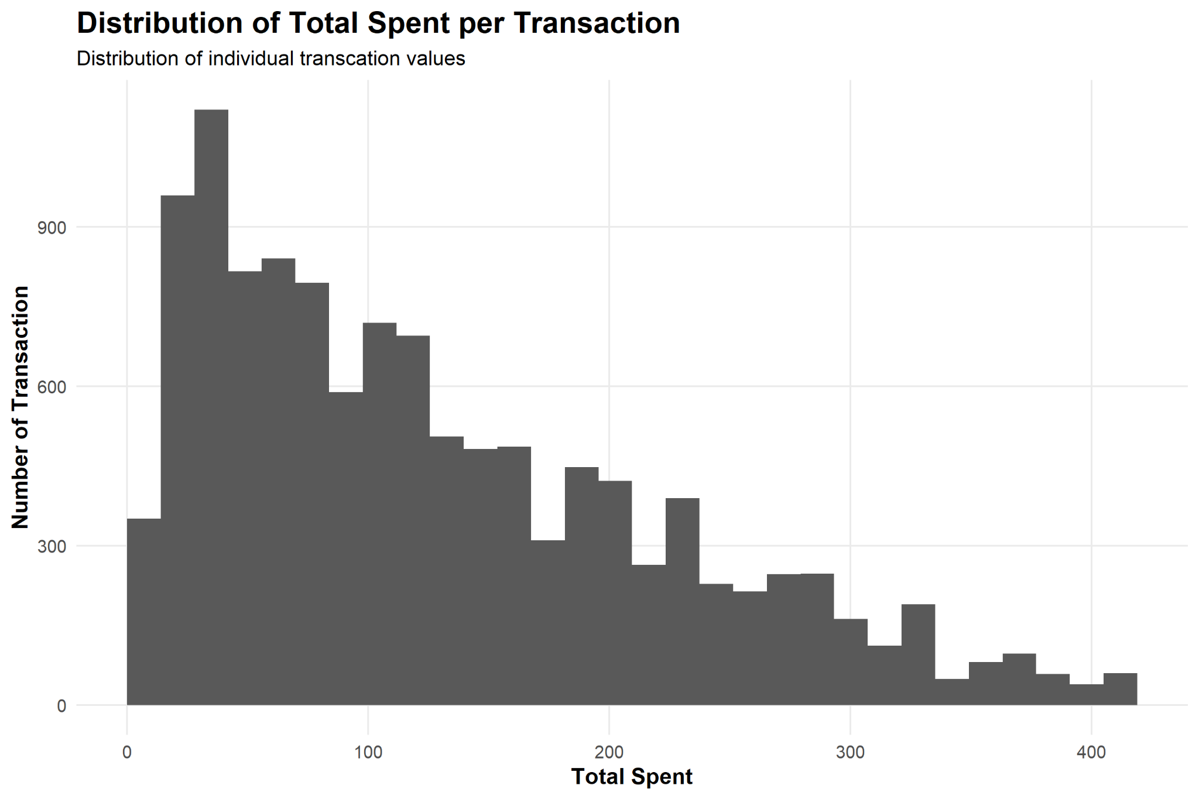
Figure 3: Distribution of Total Spent per Transaction

6.4 Interpretation
The histogram shows that the distribution of Total Spent is positively skewed, or right-skewed.
A larger concentration of transactions occurs at lower spending values, while the number of transactions generally decreases as Total Spent increases. A smaller number of transactions extend toward higher spending values, creating a right-hand tail that reaches approximately 410.
These high-value observations are consistent with the outlier investigation conducted during Task 1. Although some high transaction values may be identified as statistical outliers, they are not automatically data errors because valid combinations of Price Per Unit and Quantity can result in high Total Spent values.
Therefore, the histogram provides a clearer understanding of the overall spending distribution than summary statistics alone.

7. Visualization 4 – Relationship Between Quantity and Total Spent

7.1 Objective
The fourth visualization investigates:
How does Quantity purchased relate to Total Spent?
The preliminary correlation analysis conducted in Task 1 found:
Correlation between Quantity and Total Spent = 0.7121

7.2 Visualization Selection
A scatter plot was selected because both Quantity and Total Spent are numerical variables.
Scatter plots are useful for examining the direction, pattern, and strength of relationships between two numerical variables.
A linear trend line was also added to make the overall direction of the relationship easier to identify.

7.3 R Code
quantity_spent_plot <- ggplot(
clean_data,
aes(
x = Quantity,
y = `Total Spent`
)
) +
geom_point(
alpha = 0.35,
size = 1.5
) +
geom_smooth(
method = "lm",
se = FALSE
) +
labs(
title = "Relationship Between Quantity and Total Spent",
subtitle = "Higher quantities generally correspond to higher transaction values",
x = "Quantity Purchased",
y = "Total Spent"
) +
theme_minimal(base_size = 12) +
theme(
panel.grid.minor = element_blank(),
plot.title = element_text(
face = "bold",
size = 16
),
plot.subtitle = element_text(size = 11),
axis.title = element_text(face = "bold")
)

quantity_spent_plot
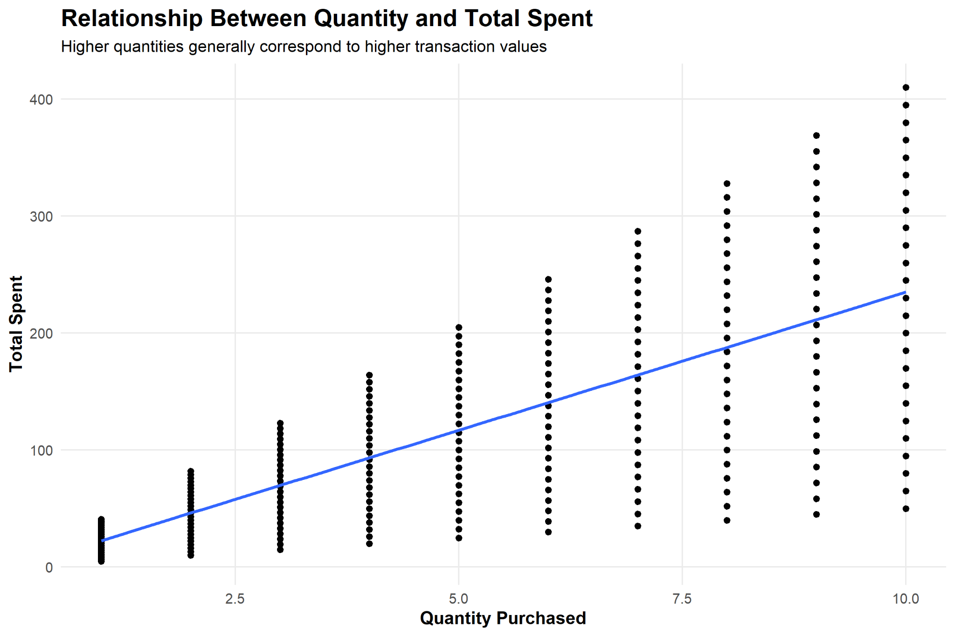
Figure 4: Relationship Between Quantity and Total Spent

7.4 Interpretation
The scatter plot shows a clear positive relationship between Quantity and Total Spent.
As the number of units purchased increases, transaction spending generally increases. The upward-sloping linear trend line visually supports the positive correlation coefficient of approximately 0.7121 obtained during the preliminary analysis.
Vertical groups of observations can be seen at Quantity values from 1 to 10. This occurs because Quantity is recorded as discrete whole-number values.
Transactions with the same Quantity can still have considerably different Total Spent values. This is expected because products have different prices per unit. For example, purchasing ten inexpensive units will produce a lower transaction value than purchasing ten expensive units.
Therefore, Quantity has a strong positive association with Total Spent, while Price Per Unit also contributes to the final transaction value.

8. Visualization 5 – Monthly Sales Trend

8.1 Objective
The fifth visualization was created to answer:
How does total sales revenue change over time?
Monthly sales were calculated by aggregating Total Spent according to Year and Month.
monthly_sales <- aggregate(
`Total Spent` ~ Year_Month,
data = clean_data,
FUN = sum
)

monthly_sales$Month_Date <- as.Date(
paste0(
monthly_sales$Year_Month,
"-01"
)
)

8.2 Visualization Selection
A line chart was selected because the data represents a sequence of monthly observations over time.
Line charts allow changes between consecutive time periods to be observed clearly and are particularly useful for identifying trends, fluctuations, peaks, and declines.

8.3 R Code
monthly_sales_plot <- ggplot(
monthly_sales,
aes(
x = Month_Date,
y = `Total Spent`
)
) +
geom_line(
linewidth = 0.9
) +
geom_point(
size = 2
) +
annotate(
"text",
x = as.Date("2025-01-01"),
y = 27000,
label = "Partial month\n(18 days)",
hjust = 1.1,
size = 3.5
) +
scale_x_date(
date_breaks = "3 months",
date_labels = "%Y-%m"
) +
scale_y_continuous(
labels = scales::comma
) +
labs(
title = "Monthly Sales Trend",
subtitle = "Monthly revenue fluctuated across the period; January 2025 contains only 18 days of data",
x = "Month",
y = "Total Sales Revenue"
) +
theme_minimal(base_size = 12) +
theme(
panel.grid.minor = element_blank(),
plot.title = element_text(
face = "bold",
size = 16
),
plot.subtitle = element_text(size = 11),
axis.title = element_text(face = "bold"),
axis.text.x = element_text(
angle = 45,
hjust = 1
)
)

monthly_sales_plot
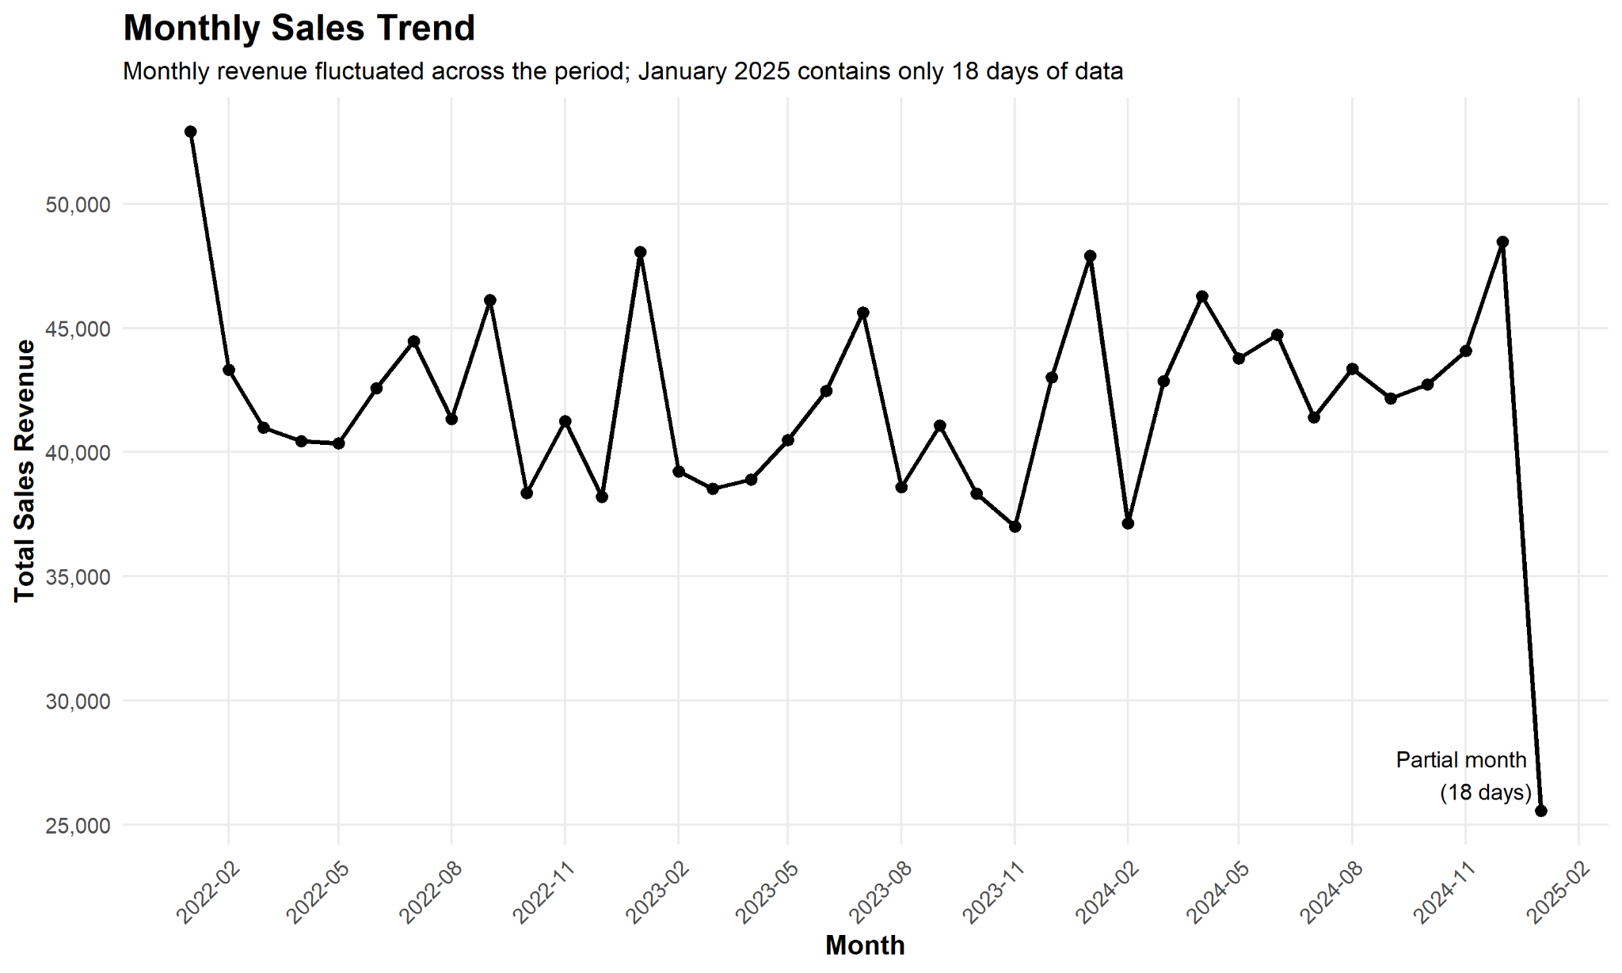
Figure 5: Monthly Sales Trend

8.4 Interpretation
The line chart shows that monthly revenue fluctuated throughout the observed period rather than following a consistent continuous upward or downward trend.
Several short-term increases and decreases occurred between 2022 and 2024, suggesting variation in monthly sales activity.
A particularly large decline appears at the final point in January 2025. However, this value requires careful interpretation.
The transaction-date range in the dataset is:
Minimum Date: 2022-01-01
Maximum Date: 2025-01-18
Therefore, January 2025 contains only 18 days of transaction data and does not represent a complete month.
The apparent decline in January 2025 should therefore not be interpreted as evidence of a sudden decline in business performance. The annotation was added directly to the visualization to prevent this partial-month observation from misleading the reader.

9. Visualization 6 – Distribution of Total Spent by Product Category

9.1 Objective
The sixth visualization investigates:
How does transaction spending vary across different product categories?

9.2 Visualization Selection
A box plot was selected because it allows the distribution of a numerical variable to be compared across multiple categorical groups.
The box plot displays information about the median, middle 50% of observations, variability, and potential statistical outliers for each category.
This provides more information than comparing only the mean or total spending value.

9.3 R Code
category_spending_plot <- ggplot(
clean_data,
aes(
x = Category,
y = `Total Spent`
)
) +
geom_boxplot() +
coord_flip() +
labs(
title = "Distribution of Total Spent by Product Category",
subtitle = "Transaction values vary across product categories",
x = NULL,
y = "Total Spent"
) +
theme_minimal(base_size = 12) +
theme(
panel.grid.major.y = element_blank(),
panel.grid.minor = element_blank(),
plot.title = element_text(
face = "bold",
size = 16
),
plot.subtitle = element_text(size = 11),
axis.text.y = element_text(size = 10),
axis.title.x = element_text(face = "bold")
)

category_spending_plot
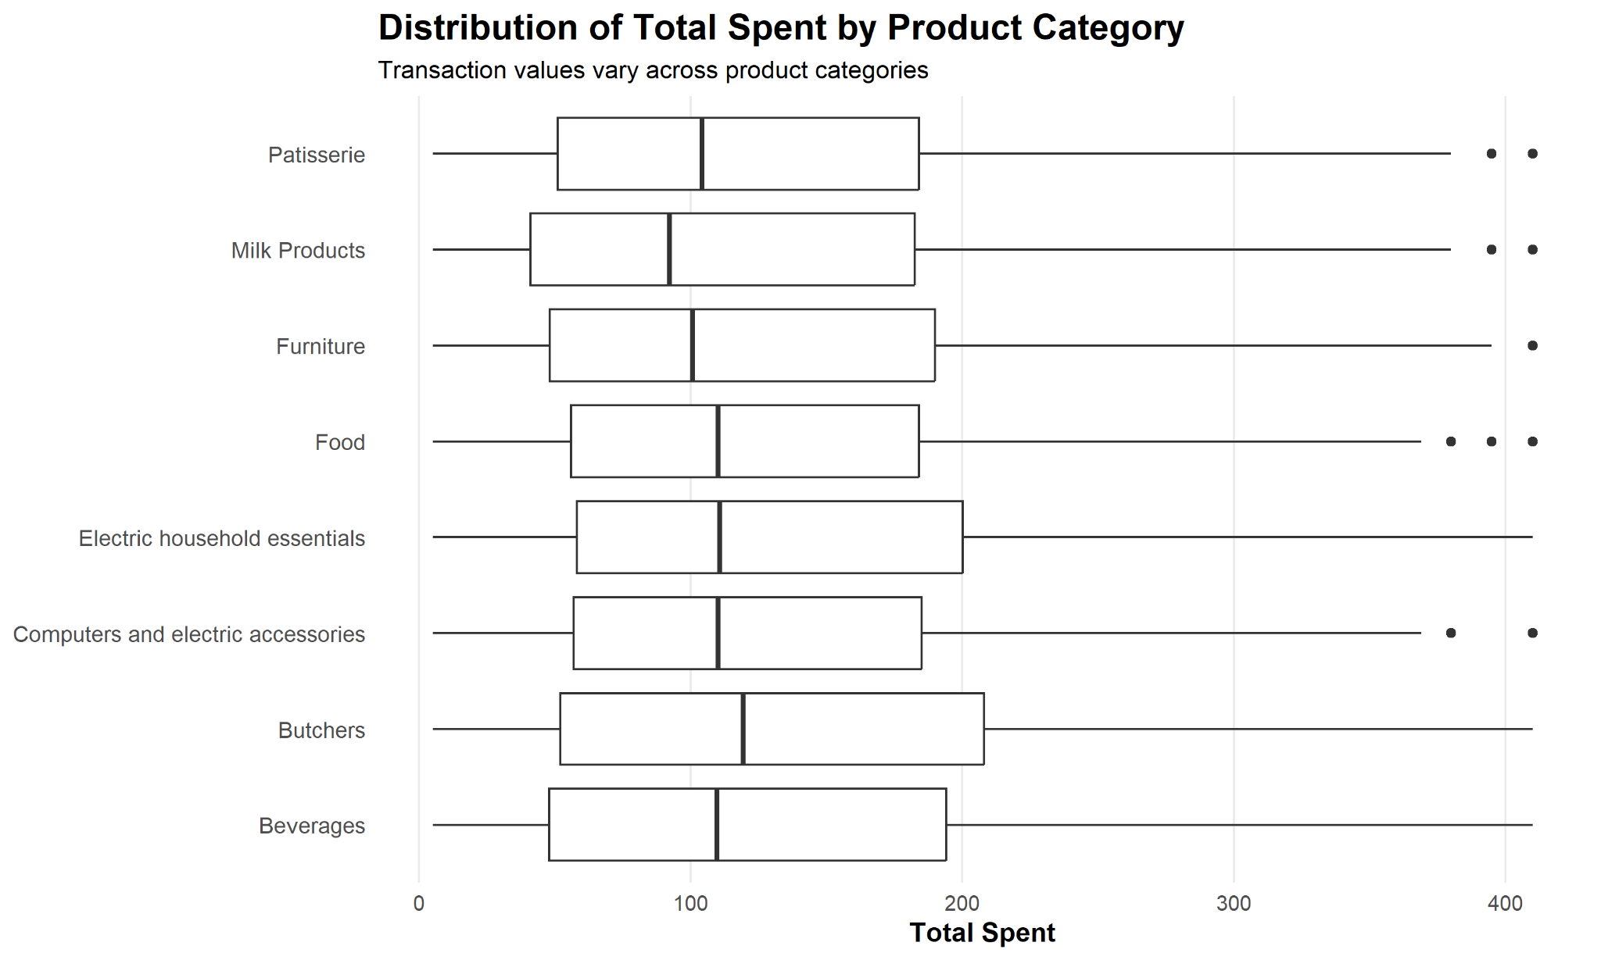
Figure 6: Distribution of Total Spent by Product Category

9.4 Interpretation
The box plot shows considerable overlap in the Total Spent distributions across the eight product categories.
The medians and interquartile ranges indicate that typical transaction values are broadly similar across several categories, although some variation in spending levels and spread is present.
The visualization also identifies several high-value observations near the upper end of the Total Spent range as potential statistical outliers.
However, these observations should not automatically be considered data errors. During the Task 1 preprocessing process, high Total Spent observations were investigated and valid transactions were retained when their values could be explained by the relationship:
Total Spent = Price Per Unit × Quantity
The box plot therefore provides useful information about both typical spending behaviour and unusually high transaction values across categories.

10. Visualization 7 – Payment Method Usage by Purchase Location

10.1 Objective
The final visualization was designed to answer:
Does payment-method usage differ between Online and In-store transactions?
The number of transactions for each combination of Location and Payment Method was calculated using:
payment_location <- as.data.frame(
table(
clean_data$Location,
clean_data$`Payment Method`
)
)

names(payment_location) <- c(
"Location",
"Payment_Method",
"Count"
)

payment_location
The resulting counts were:
Payment Method | In-store | Online
Cash | 2,032 | 2,071
Credit Card | 1,918 | 2,009
Digital Wallet | 1,953 | 1,988

10.2 Visualization Selection
A grouped bar chart was selected because it allows the frequency of each Payment Method to be directly compared between Online and In-store locations.
Placing the bars side by side makes relatively small differences easier to identify than a stacked bar chart.

10.3 R Code
payment_location_plot <- ggplot(
payment_location,
aes(
x = Payment_Method,
y = Count,
fill = Location
)
) +
geom_col(
position = position_dodge(width = 0.8),
width = 0.7
) +
geom_text(
aes(label = Count),
position = position_dodge(width = 0.8),
vjust = -0.4,
size = 3.8
) +
scale_y_continuous(
limits = c(0, 2300),
breaks = seq(0, 2000, 500)
) +
labs(
title = "Payment Method Usage by Purchase Location",
subtitle = "Payment preferences were relatively balanced across locations",
x = "Payment Method",
y = "Number of Transactions",
fill = "Purchase Location"
) +
theme_minimal(base_size = 12) +
theme(
panel.grid.major.x = element_blank(),
panel.grid.minor = element_blank(),
plot.title = element_text(
face = "bold",
size = 16
),
plot.subtitle = element_text(size = 11),
axis.title = element_text(face = "bold"),
legend.position = "top"
)

payment_location_plot
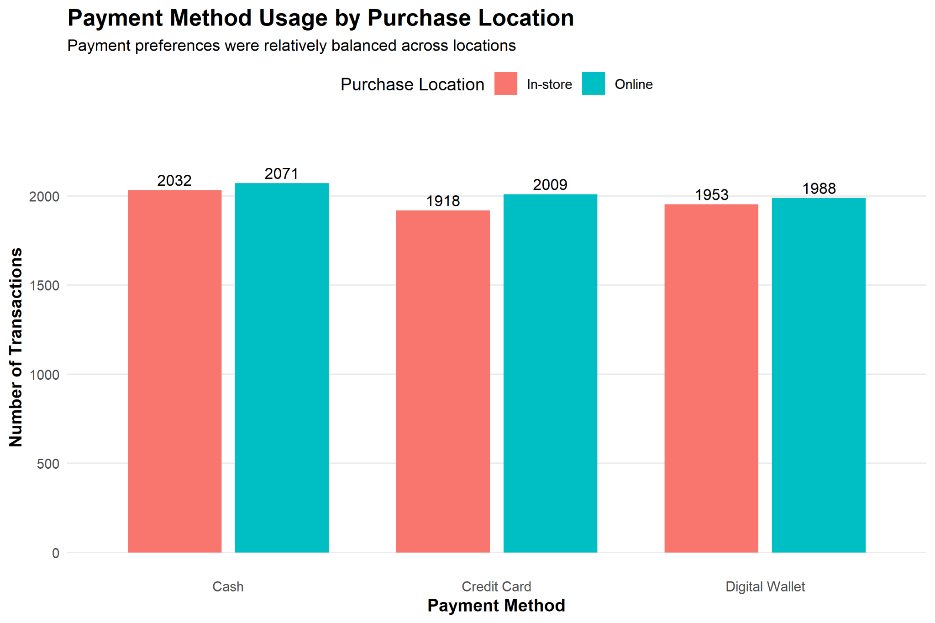
Figure 7: Payment Method Usage by Purchase Location

10.4 Interpretation
The grouped bar chart shows that payment-method usage was relatively balanced between Online and In-store transactions.
For Cash payments, there were 2,071 Online transactions compared with 2,032 In-store transactions.
For Credit Card payments, there were 2,009 Online transactions compared with 1,918 In-store transactions.
For Digital Wallet payments, there were 1,988 Online transactions compared with 1,953 In-store transactions.
Online transactions were therefore slightly more frequent for all three payment methods. However, the differences were relatively small.
The visualization does not indicate a strong location-specific payment preference. Instead, Cash, Credit Card, and Digital Wallet were all commonly used across both Online and In-store transactions.

11. Exporting High-Quality Visualizations
To ensure that the visualizations remained clear when inserted into the final report, the completed graphs were exported directly from R rather than relying only on screenshots.
The ggsave() function was used with a resolution of 300 DPI.
For example:
ggsave(
"plots/01_quantity_by_category.png",
plot = quantity_category_plot,
width = 10,
height = 6,
dpi = 300
)
The same approach was used for all seven visualizations.
The final exported files were:
01_quantity_by_category.png
02_revenue_by_location.png
03_total_spent_histogram.png
04_quantity_vs_total_spent.png
05_monthly_sales_trend.png
06_total_spent_by_category_boxplot.png
07_payment_method_by_location.png
Exporting the graphs at high resolution ensures that titles, labels, values, and graphical elements remain readable when included in the final document.

12. Key Insights
The visual analysis produced several important findings.
Product performance: Furniture recorded the highest total quantity sold with 8,462 units, while Patisserie recorded the lowest with 7,943 units. However, quantities were relatively evenly distributed across all eight categories.
Purchase location: Online transactions generated 791,401 in total revenue compared with 760,670 from In-store transactions. Online therefore generated slightly higher revenue, although both locations contributed substantially to overall sales.
Transaction-value distribution: Total Spent followed a right-skewed distribution. Lower-value transactions occurred more frequently, while progressively fewer transactions occurred at higher spending levels.
Quantity and spending relationship: Quantity showed a clear positive relationship with Total Spent. The scatter plot and upward-sloping trend line support the previously calculated correlation of approximately 0.7121.
Sales over time: Monthly revenue fluctuated across the observed period without displaying a consistent continuous upward or downward trend. The apparent decline in January 2025 represents a partial month containing only 18 days of data and should therefore not be interpreted as a sudden decline in business performance.
Spending across categories: The box plot showed considerable overlap in transaction-spending distributions across product categories. Some high-value observations appeared as statistical outliers, but these were not automatically considered errors because valid transactions can produce high Total Spent values.
Payment behaviour: Cash, Credit Card, and Digital Wallet usage was relatively balanced across Online and In-store transactions. No payment method demonstrated a strong location-specific preference based on the observed transaction counts.

13. Conclusion
This task demonstrated how data visualization can be used to communicate patterns, relationships, distributions, and trends within a retail sales dataset.
The cleaned Retail Store Sales dataset prepared during Task 1 was used to develop seven visualizations using R and ggplot2. Different visualization techniques were selected according to the analytical question and variable types rather than applying the same chart type throughout the analysis.
Bar charts were used to compare product-category quantities and revenue by purchase location. A histogram was used to investigate the distribution of transaction spending. A scatter plot was used to visualize the relationship between Quantity and Total Spent. A line chart was used to examine monthly sales patterns. A box plot was used to compare transaction-spending distributions across product categories, while a grouped bar chart was used to compare payment-method usage across purchase locations.
The visualizations revealed that Furniture recorded the highest quantity sold, while Online transactions generated slightly higher total revenue than In-store transactions. Transaction spending was right-skewed, and Quantity showed a clear positive relationship with Total Spent. Monthly sales fluctuated throughout the observed period, while payment-method usage remained relatively balanced across purchase locations.
Care was also taken to avoid misleading interpretations. In particular, the January 2025 sales observation was explicitly identified as a partial month containing only 18 days of data, and statistical outliers were interpreted in the context of the underlying transaction values rather than automatically being treated as errors.
Overall, the visualizations provided a clear and accessible representation of the major patterns in the Retail Store Sales dataset and demonstrated how R can be used to transform numerical analysis into meaningful graphical insights for both technical and non-technical audiences.

